# Watsonx Orchestrate Lab 1a:

# Out of the Box Skills

Objective:

Welcome to watsonx Orchestrate Lab. Watsonx Orchestrate runs on applications and skills. To start off, we will walk through how to connect and use the out of the box skills and use it within the AI Chat.

Use Case:

In this lab, you will learn how to connect to salesforce with watsonx orchestrate, add prebuilt skills of salesforce and how to use in AI chat. Credentials for this lab can be found here.

Connecting to watsonx Orchestrate

1. Login to watsonx Orchestrate (<https://dl.watson-orchestrate.ibm.com>) using your IBM Cloud email id and password. If you have trouble locating your username and password, please contact an IBM-er.

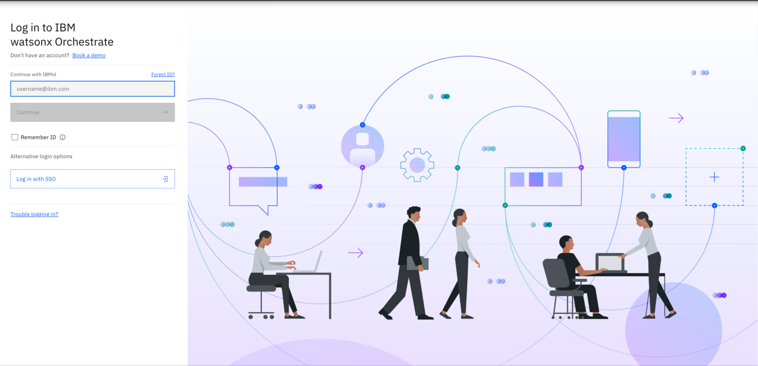

1. You will land on watsonx Orchestrate homepage. Click on Skill Catalog on the left hand hamburger menu

Next select “Personal Skills” and click “Go to skill Catalog”

1. Search “Salsesforce” App in the given Application tiles under Personal skills.

1. Search for “Product” in the search bar and select “Get all Products”. click “Add skill”

1. Repeat the above steps to add in “Get all Pricebooks” and “Get all Accounts” by searching “Account” and “Price” in the search bar. Add all the respective skills.

1. The above skills do not require any credentials as an admin have already connected it into this instance.
2. Next, we will try one skill which requires you to add in the credential on your own.
3. In the next steps, we will be showing how to connect to the Send an email skill from either Gmail/Outlook.
   1. For Gmail, you will be using your own “Gmail” credentials
   2. For Outlook, refer to the [connection details sheet](https://ibm.box.com/s/jxu2x9lc8z2iiw0i2i5wjd6mggykzkjc) and use the outlook credentials given to you. (Your IBM Credentials will not work)
4. Let’s go back to main skill catalog page by simply clicking on the **Skill Catalog** at the left corner of the page.

You will see the following screen.

Here, you can add either of the skills as per your choice.

Till now, you have learned how to select the specific applications (App) and their respective skill sets to your Personal skill sets which can be used further. Let’s move to the next step.

Configure AI Agent with Custom Skill

Note:

* For this workshop, we’ve given everyone admin rights. If you notice you’re not one, feel free to contact the course owner.
* **For this workshop, we’ve added all apps and skills required to complete this lab. You can follow through the steps, but now onwards you DO NOT NEED to connect or add on any of the skills anymore.**
* **DO NOT** edit any skills credentials

1. Go to “Skill Sets” from the top left hamburger menu.

1. From the dropdown menu “Team Skills” please select “Orchestrate Agent Skillset”.

1. After selecting “Orchestrate Agent Skillset”, select “Connections”

1. Under Connections tab search for “Gmail” **or** “Outlook”

1. Click on the triple dots at the end of the row and click on “Connect app”. Follow the instructions to authenticate.

1. Navigate to the ‘AI Agent Configuration’ under “Build” from the left hamburger menu.

You will see the following page.

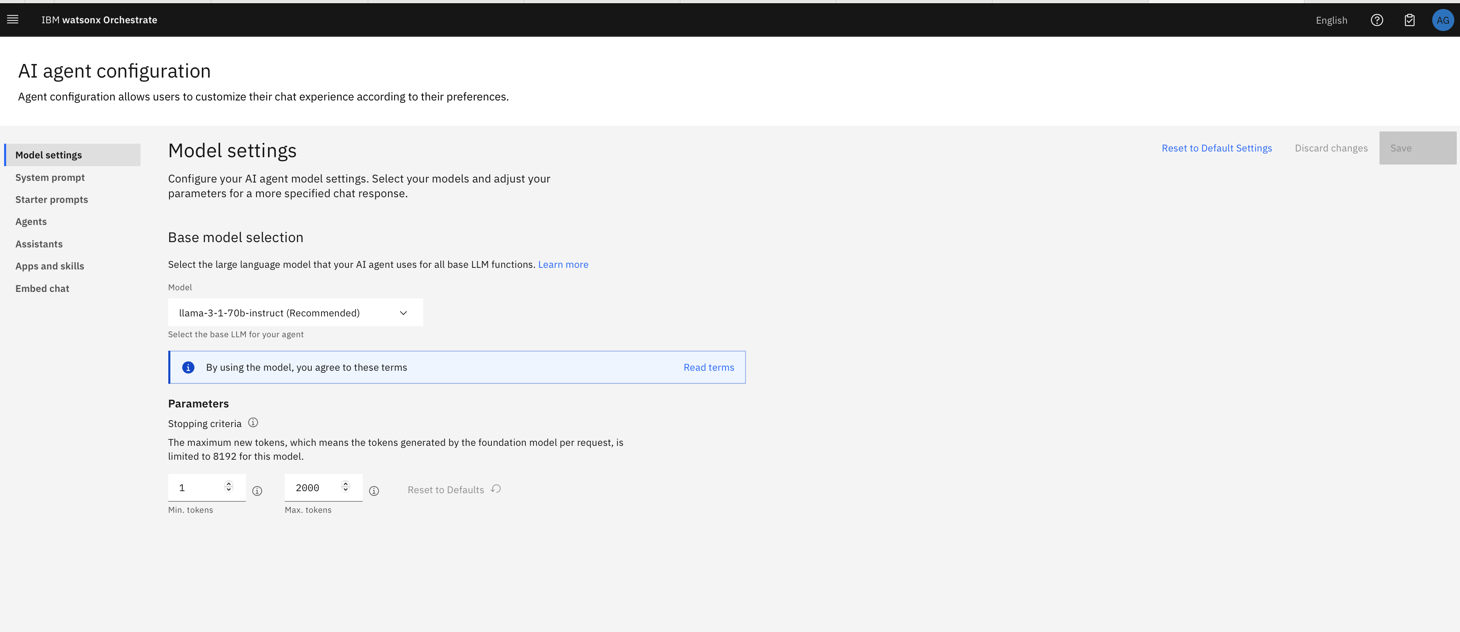

1. Select “Apps and Skills” and search for SalesforceA screenshot of a computer

   AI-generated content may be incorrect.
2. Click on the Salesforce tile.

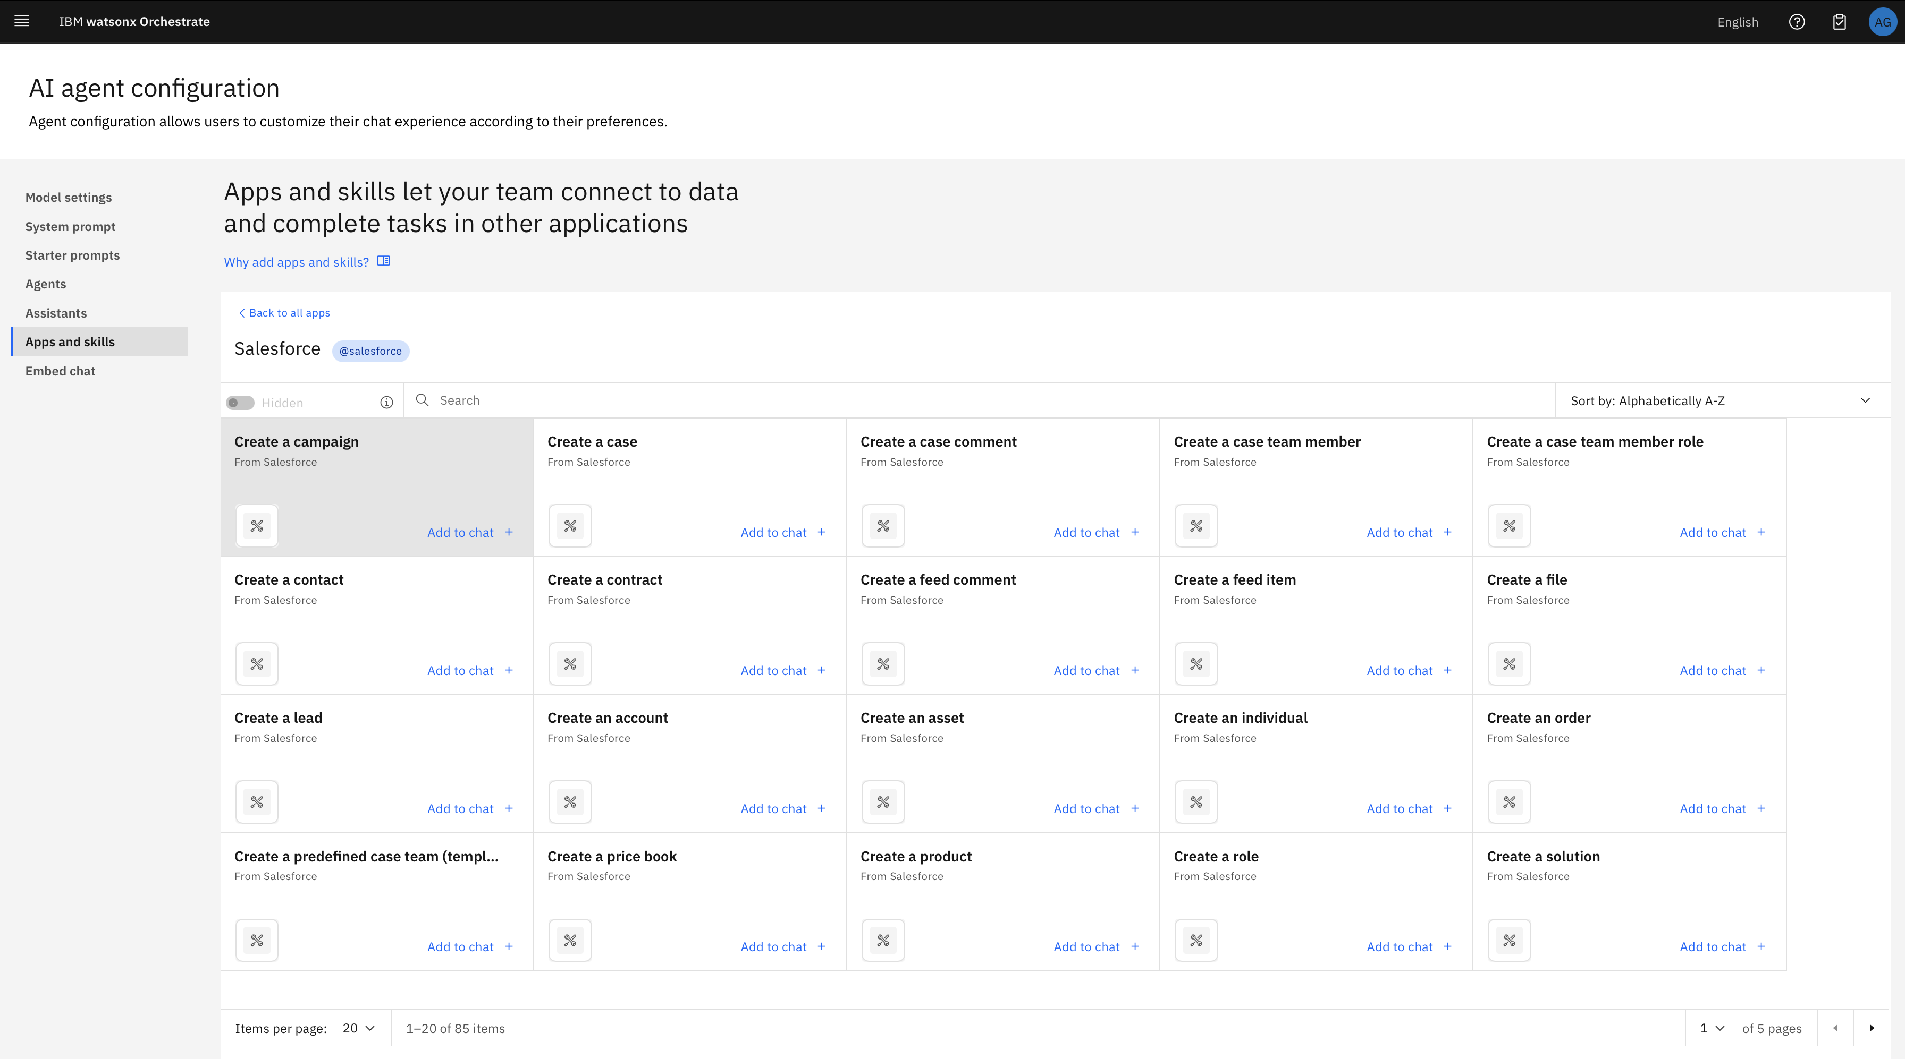

1. Search for “Get All Product” and click “Add to chat”. If it is already added, please ignore and move to step 15. A screenshot of a computer

   AI-generated content may be incorrect.
2. Give a description to this skill and click “Add Skill”. Be as descriptive.

1. Repeat steps 9 and 10 to add “Get all accounts” to the configuration. If it is also added already, please ignore and move to next step.
2. Now, you are ready to use “Get all accounts” skills in your AI chat. Click on chat option from the left hamburger menu.

Next select “New Chat”

1. Type skill name and you can see the response. You can use these skills in your assistant. Click on new chat, type in chat “get all accounts”.

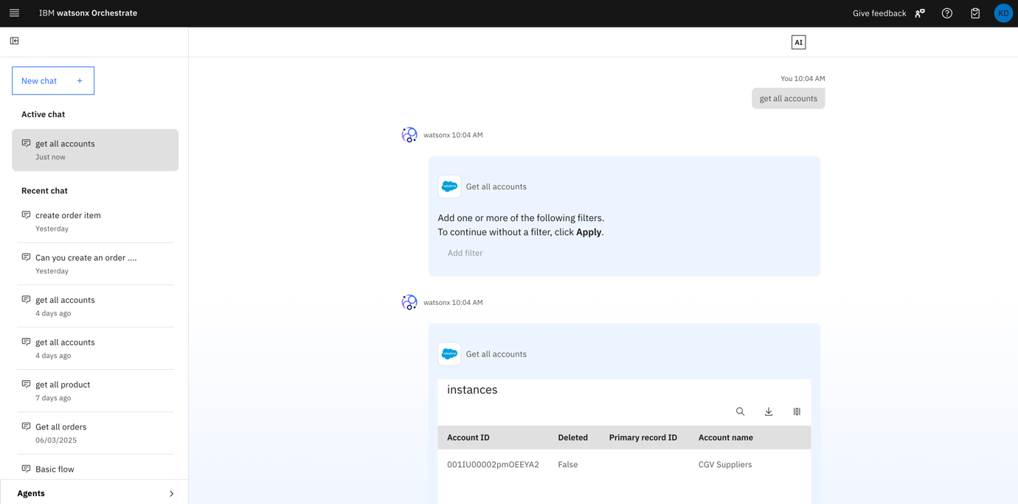

1. If time permits, you may the above steps to add in the “Gmail” or “Outlook” skills into the AI agent Configuration and test out the Send Email function.

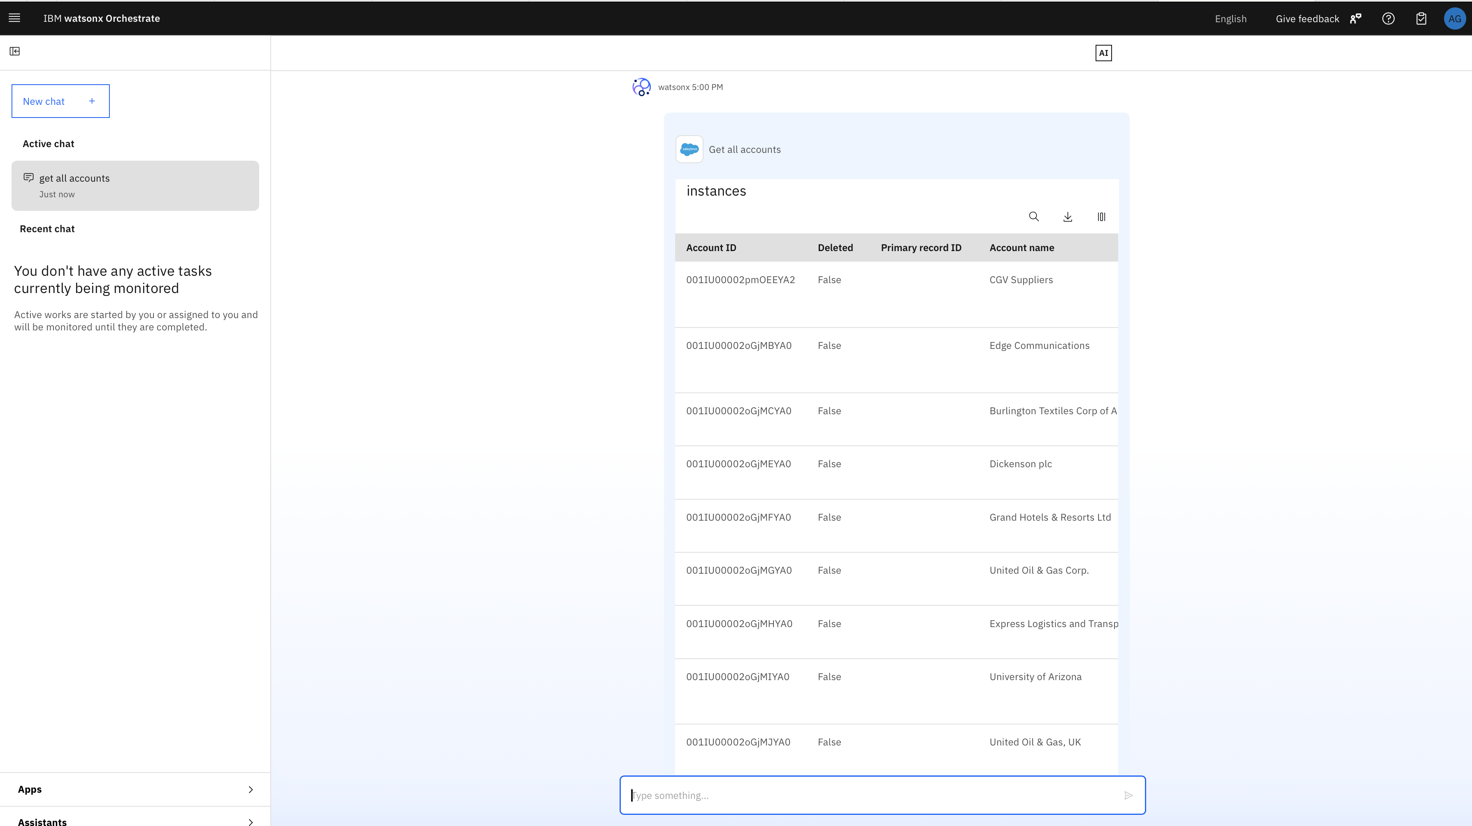

This is the end of the Lab 1a.